**ASSIGNMENT 2**

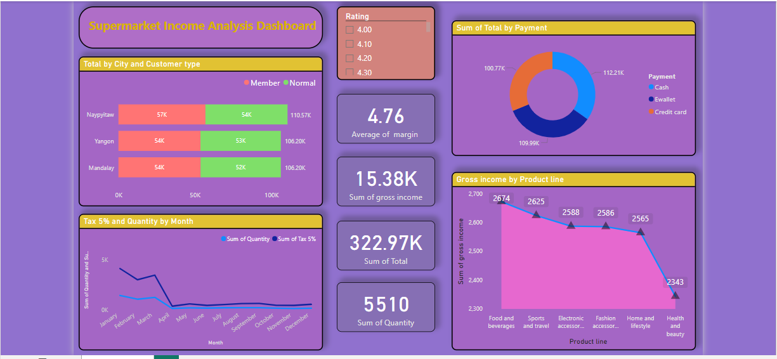

* **Key Findings and Insights from the Supermarket Income Analysis Dashboard**

1. **City-Wise Sales & Payment Trends:**
2. Sales are almost the same in **Naypyitaw, Yangon, and Mandalay**. (around ₹106K - ₹110K)
3. Members and normal customers spend similarly.
4. **Payment Method Trends:**
5. Most customers prefer Credit Cards (₹112.21K)
6. **Cashless payments are more popular** than cash.
7. **Sales Trends Over Months:**
8. **Sales were highest in Jan-April** but dropped after May.
9. This could be due to **seasonal demand changes**.
10. **Best and Worst Selling Product Categories:**
11. **Food & Beverages made the most profit (₹2,674).**
12. **Health & Beauty had the lowest income (₹2,343),** meaning fewer people buy these products.
13. **Overall Income Performance:**
14. Total **5510** units of Quantity are sold.
15. Total ₹322.97K are earned form all sales.
16. Total ₹15.38K is gross income earnings after product costs.
17. Total 4.76% is gross margin.